Title : Signal Processing

Course: E&EE Final Year

Date: 12_03_2001

Ideas

The gain K.

The effect of varying the gain K in the transfer function is that it raises or lowers the log-magnitude curve of the transfer function by the corresponding constant amount, but has no effect on the phase curve.
A number-decibel conversion is shown below. As a number increases by a factor of 10, the corresponding decibel value increases by a factor of 20. This may be seen from the following:

20 log(K x 10) = 20 log K + 20 log 10

= 20 log K + 20

Integral factors (jw)⁻¹ i.e. 1/jw.

The logarithmic magnitude of 1/jw in decibels is

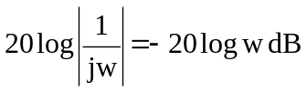

The phase angle of 1/jw is constant and equal to -90°.
In Bode diagrams, frequency ratio’s are expressed in terms of octaves or decades. An octave is a frequency band from w₁ to 2w₁, where w₁ is any frequency value. A decade is a frequency band from w₁ to 10w₁, again where w₁ is any frequency.
If the log magnitude –20logw dB is plotted against w on a logarithmic scale, it is a straight line. To draw this line, we need to locate one point (0 dB, w =1) on it. Since

(-20 log 10w) dB = (-20 log w – 20) dB

The slope of the line is –20 dB/decade (or –6 dB/octave).

Derivative factor (jw)

Similarly, the log magnitude of jw in decibels is

20 log |jw| = 20 log w dB

The phase angle of jw is constant and equal to 90°. The log magnitude curve is a straight line with a slope of 20 dB/decade.

Figures 1.1 and 1.2 show frequency-response curves for 1/jw and jw, respectively. We can clearly see that the differences in the frequency responses of the factors 1/jw and jw lie in the sign of the slopes of the log magnitude curves and in the signs of the phase angles. Both log magnitudes become equal to 0 dB at w=1.

40
dB

1
10
100
-40
0.1
-20
0
20
40
dB
0

1
10
100
-40
0.1
-20
20
w
w

φ
0°
φ
180°
-90°
90°

-180°
0°
1
10
100
0.1
w
1
10
100
0.1
w

Figure 1.1 Bode diagram of G(jw) = 1/jw Figure 1.2 Bode diagram of G(jw) = jw

Because a low pass filter is required, as shown in Figure 1.1 an integrating factor is required. However as stated in the design specification a cuttoff frequency at 2kHz is required 3dB’s down from the pass band and 40dB per decade roll-off. The transfer function G(jw) = 1/jw gives a frequency response with a 20 dB/dec roll off.

Plotting a Bode diagram with Matlab

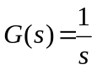

When the system is defined in the form

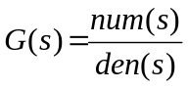

Using the command bode(num,den) to draw the Bode diagram. [When the numerator and denominator contain the polynomial coefficients in descending powers of s, bode(num,den) draws the bode diagram.] MATLAB Program 1-1 shows a program to plot the Bode diagram for this system. The resulting Bode diagram is shown in Figure 1.3.

Num = [0 1]
Den = [1 0]
Bode(num,den)
MATLAB Program 1-1

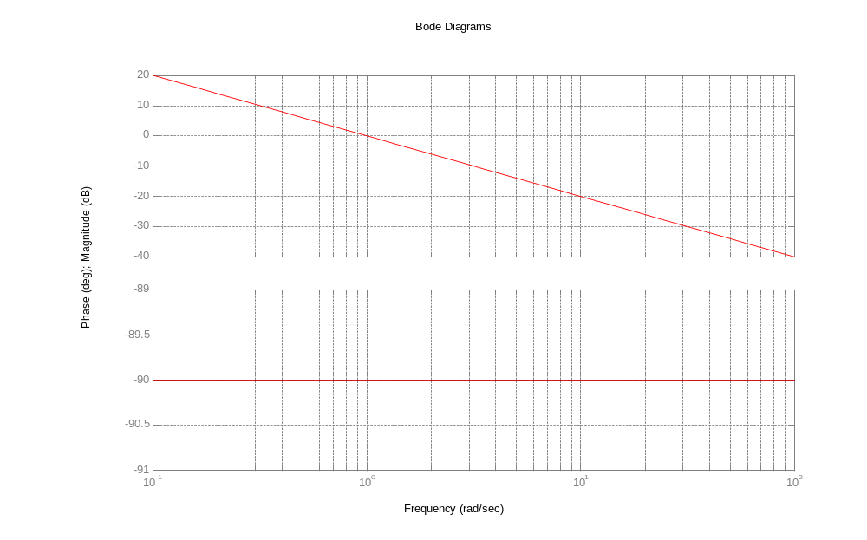

Figure 1.3 Bode diagram of G(s) = 1/s

First-order factors 1/(1 + jwT)

The log magnitude of the first-order factor 1/(1 + jwT) is

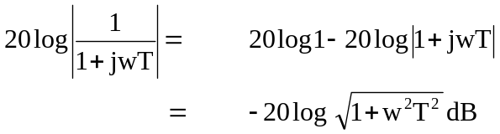

For low frequencies, such that w << 1/T, the log magnitude may be approximated by

Thus, the log-magnitude curve at low frequencies is the constant 0-dB line. For high frequencies, such that w >> 1/T,

Lab 1

Qu 4)

For each of the following systems, determine whether it is likely to be stable. (will a finite input generate a finite output?)

i). A system with no zeros and a pole at the origin.

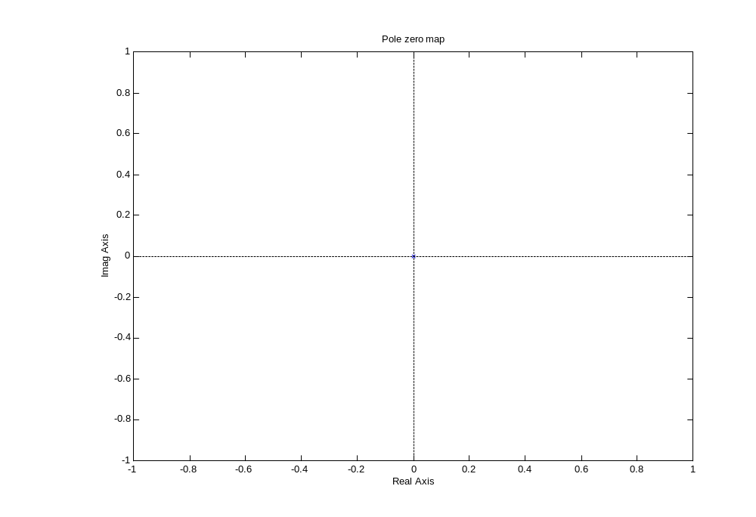
Figure A system with no zeros and a pole at the origin

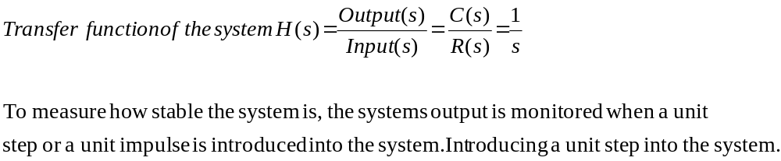
System response to a Step Input

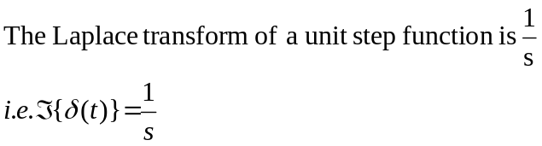
Substituting 1/s back into the system transfer function we have:-

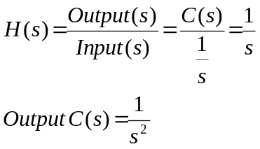

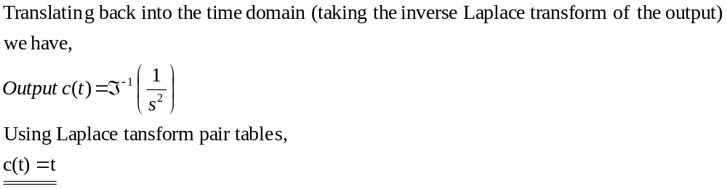
Hence the system response to a unit-step function is proportional with time (as shown below).

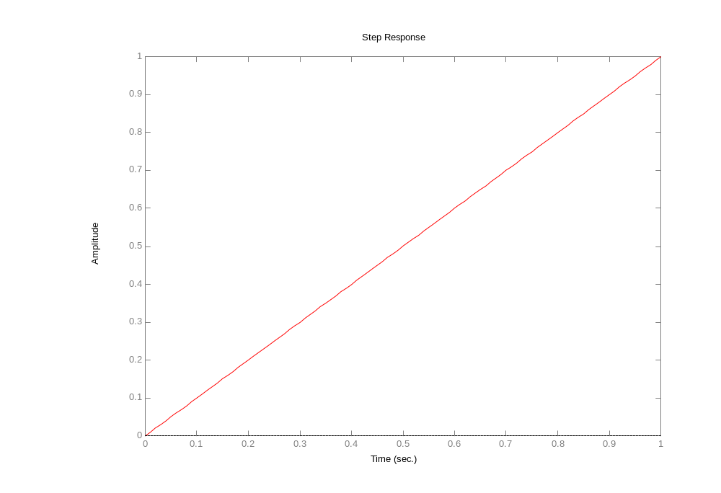
Figure Step response of system with no zeros and a pole at the origin

System response to Unit impulse

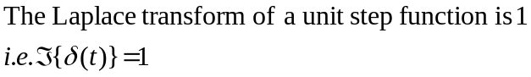

Substitute this value back into the transfer function equation

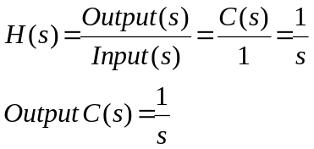

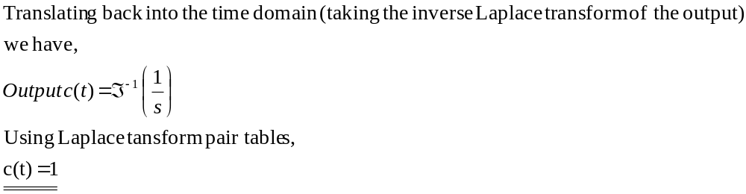

Hence the system response to a unit-impulse function for all time is 1 (as shown below).
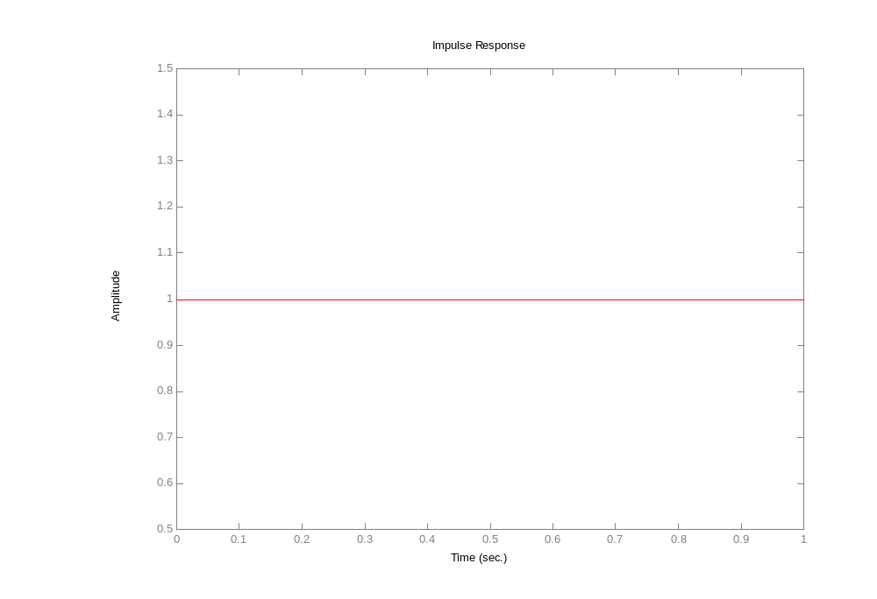
Figure Impulse response of system with no zeros and a pole at the origin

System Frequency response

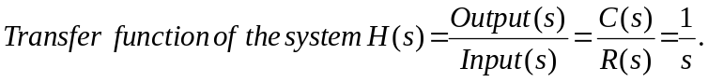

To achieve the frequency response substitute jw in for s in G(s)

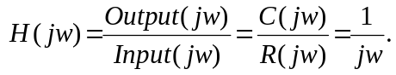

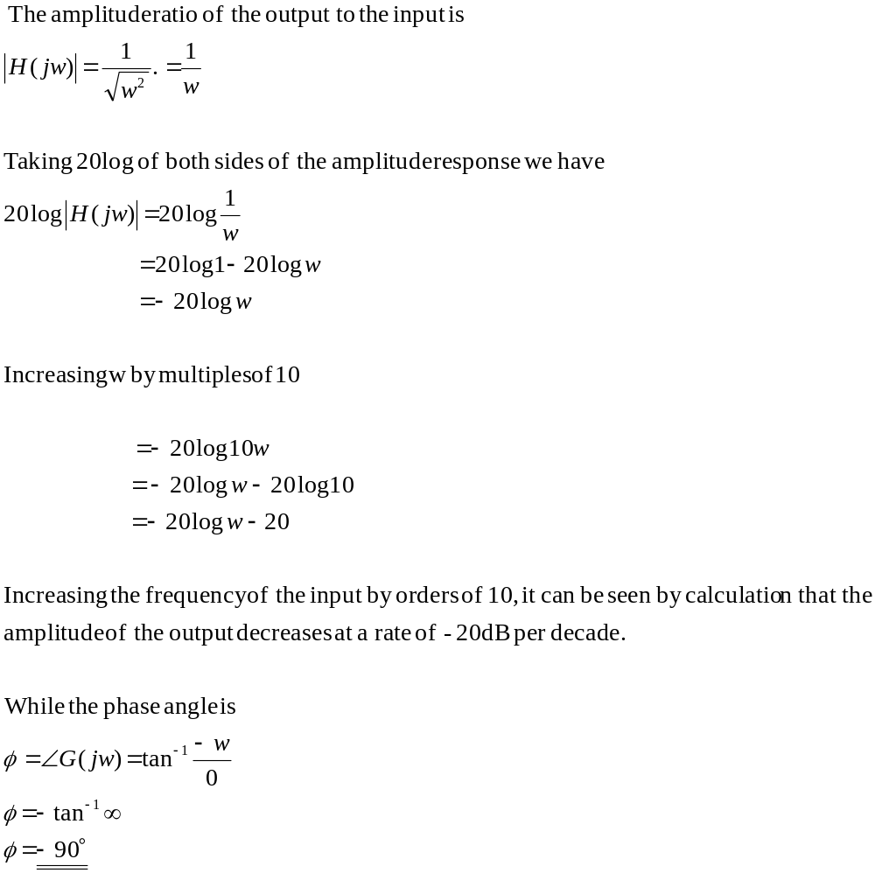
This information can be shown in the bode plot using MATLAB.

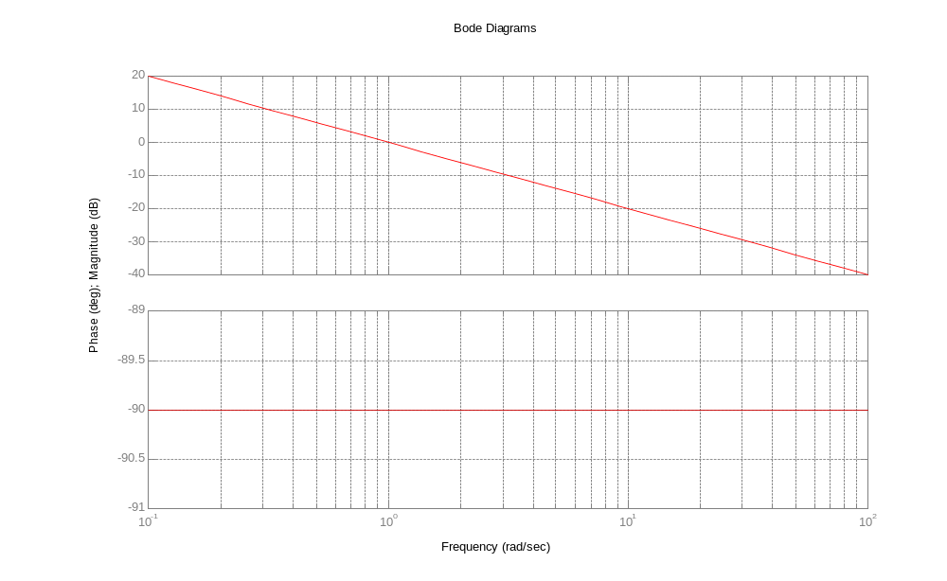
Figure A bode plot of the transfer function 1/s
i). A system with no zeros and poles on the negative σ axis.

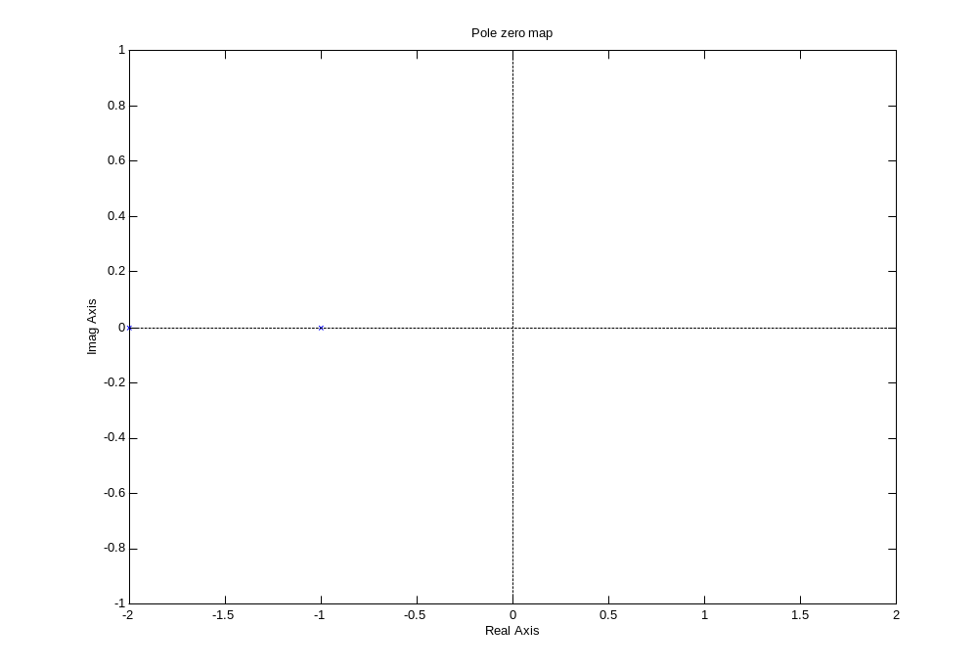
Figure A system with no zeros and poles on the negative axis

z=[]; p=[-1, -2]; k=1;
[num, den]=zp2tf(z, p, k);

MATLAB Program 1-1

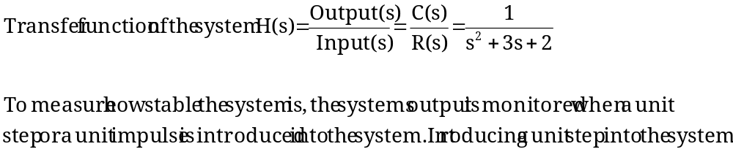

System response to a Step Input

The laplace transform of a step input is 1/s.

I won’t bother manually calculating the different responses, just look at the MATLAB results below:-

ii).
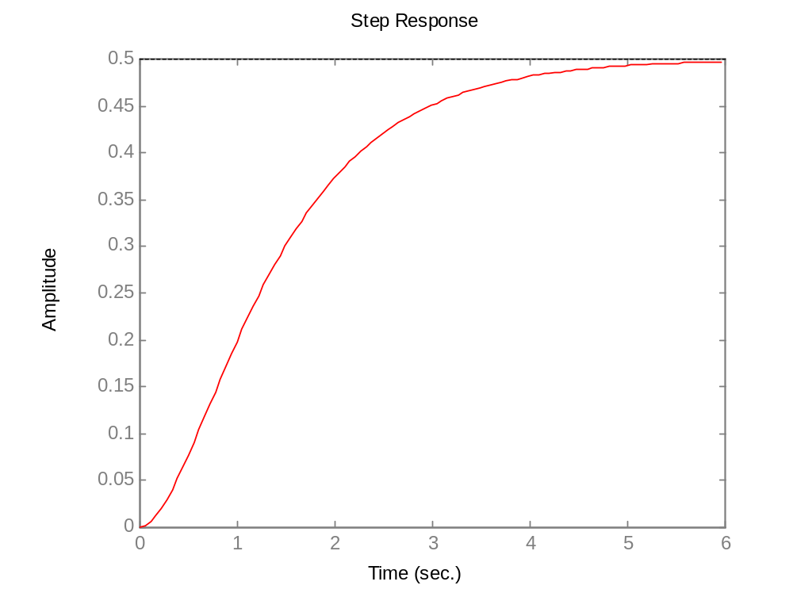
A system with no zeros and poles on the negative σ axis.

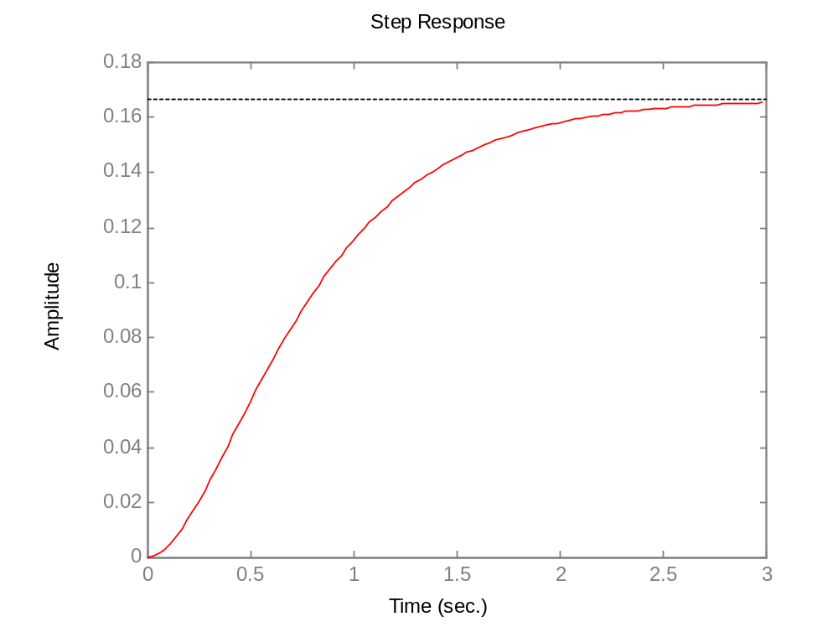
A system with no zeros, and more negative poles on the negative σ axis.

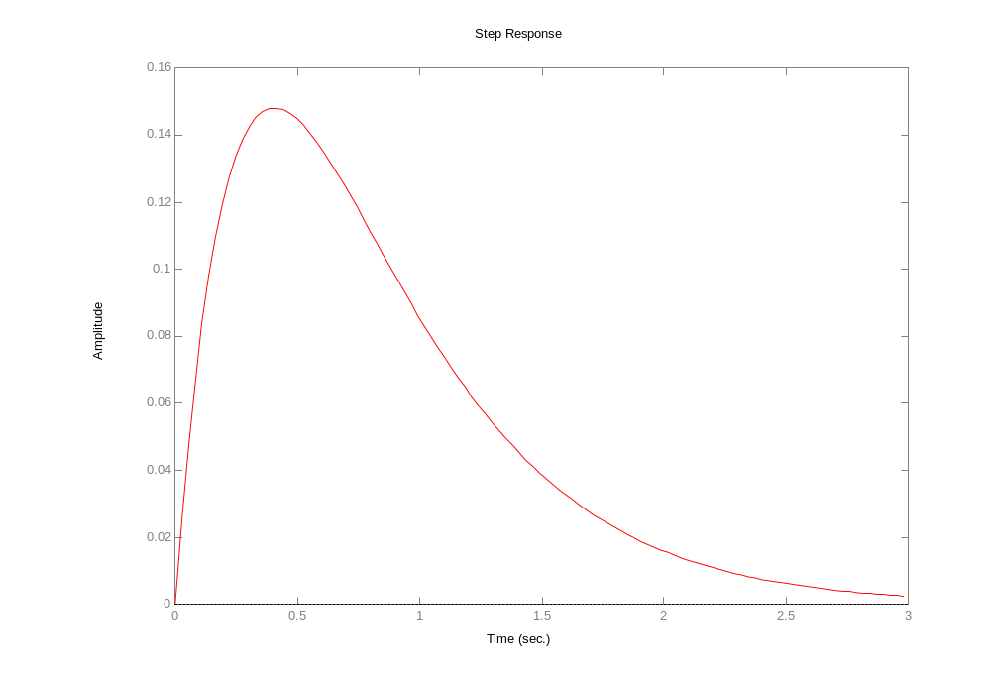

Adding a zero at the origin

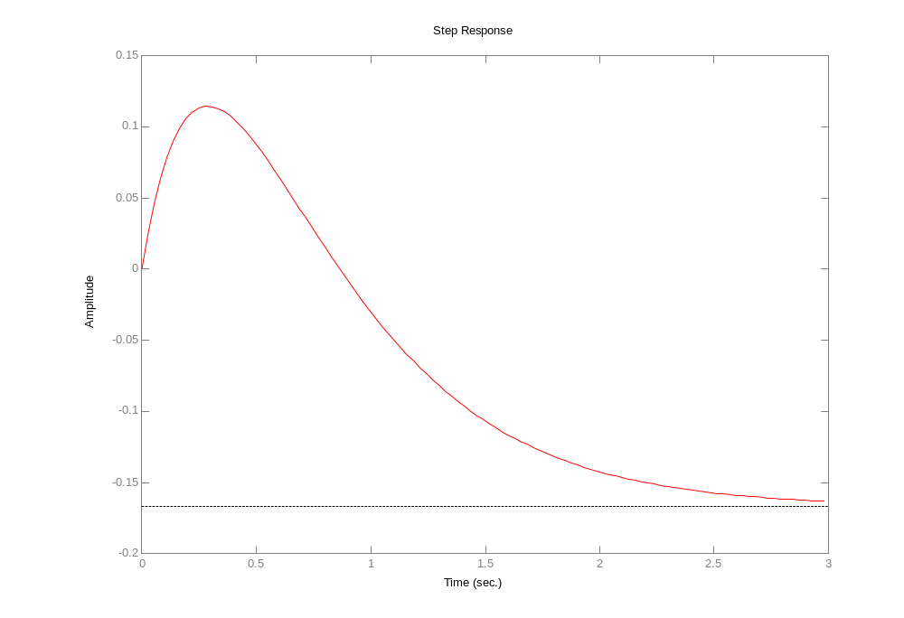
Adding a zero at σ = 1

